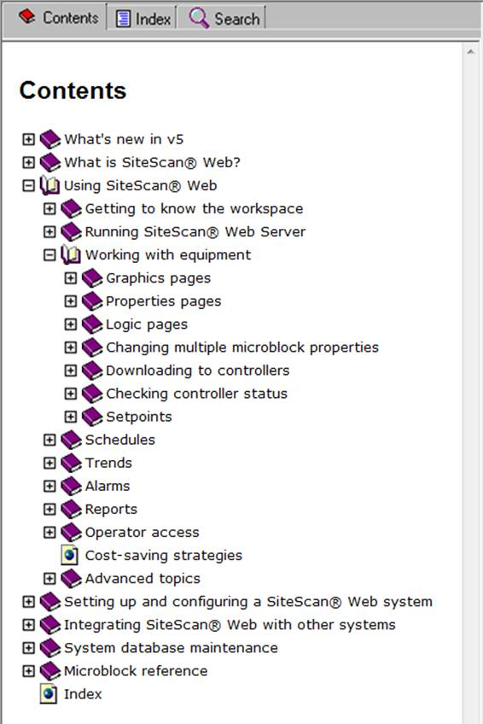

**What is SupplyMedium®?**

SupplyMedim® Web is a web-based office automation system that can be accessed from anywhere in the world through Internet Explorer, without the need for special software on the workstation. Through Internet Explorer, you can perform most office management functions such as:

* + Make your own company website

### UI Design

Key points: Simple, intuitive, usability point of view, smooth user experience

Wire frames for various scenarios are as illustrated below:

### Log in /Register

The first person to register for a particular company will get the tag of an admin. However Admin can give or share admin role with any other user. Only an Admin can add or delete or update a user. Any regular user signup needs to be approved by an Admin before he can get access to company’s profile.

Landing Page:

* + This will be similar to Facebook login except that the company has to be first registered and only then individual employees (users) of that company can register.

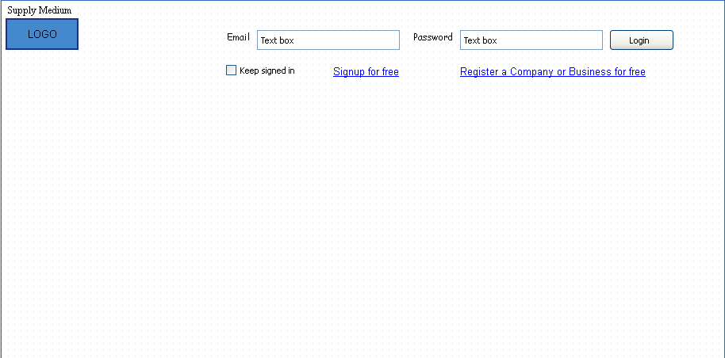

**Company Registration:**

* + The person registering the company automatically takes over as the admin of that company but he has the rights to add other employees as admin as well.
  + List of company categories for the drop down is part of the appendix
  + User will only come to this screen if and only if the company is NOT yet registered and he wants to register the company
  + Company name along with Country together will be unique e.g. a company can be based in America and India and may be named as XYZ with country as USA and XYZ with country as India or anywhere else in the world.

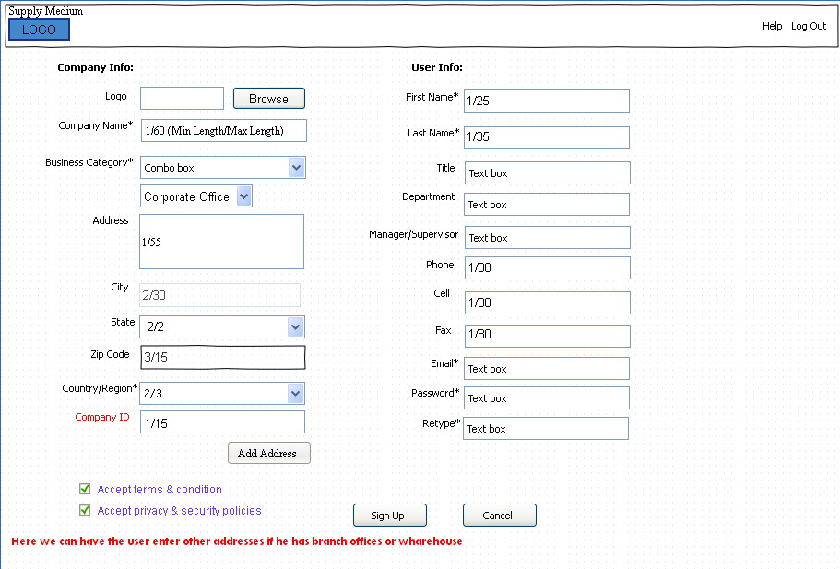

|  |  |  |  |  |
| --- | --- | --- | --- | --- |
| Company Fields | Status | Max/Min | Type | Description |
| Sign Up As | M |  |  | A company or business can register as buyer, supplier or Both. In case the company registers as both they will have buyers and suppliers privileges. Both is selected by default. |
| Logo | O | - |  | The administrator can add the company logo. The logo is added as a png or jpg,………This logo will be displayed on all the company pages. |
| Company Name | M | 1/60 |  | The Company/Organization the individual works for. In case the individual is added by the administrator this field will be populated by default. |
| Company ID | M | 1/15 |  | A unique identifier designating the company |
| Business Category | M | - |  | A basic category of business activity. The term is sometimes used to describe a very precise business activity (e.g. semiconductors) or a more generic business activity (e.g. consumer durables). |
| Segment/Division Name | O |  |  |  |
| Business Unit Name | O |  |  |  |
| Branch | O |  |  |  |
| Country/Region | M | 2/3 |  | Code identifying the country. U.S is selected by default. |
| Address | O | 1/55 |  | Company/Business Address information |
| City | O | 2/30 |  | Company/Business free-form text for city name |
| State | O | 2/2 |  | Code (Standard State/Province) as defined by appropriate government agency |
| Zip | O | 3/15 |  | Code defining international postal zone code excluding punctuation and blanks (zip code for United States) |
| Add Address |  |  |  |  |
| **User Fields** | **Status** | **Max/Min** | **Type** | **Description** |
| First Name | M | 1/25 |  | Individual first name |
| Last Name | M | 1/35 |  | Individual last name |
| Title | O |  |  | Individual title in the company often used as a means of identifying his/her function in the organization. |
| Department | O |  |  | A business is normally organized by its functions, e.g. marketing department, accounts department and so on. This is because being grouped together allows the functions to benefit from specialization and division of labor. |
| Manager/ Supervisor | O |  |  | The person in the organization the individual reports to. |
| Primary Phone | M | 1/80 |  | Office Phone Number |
| Cell | O | 1/80 |  | Cell phone |
| Fax | O | 1/80 |  | Fax Number |
| Email | M |  |  | Individual email. This should be other than the individual email assigned by SupplyMedium. This email address will be used to send the individual username and password when he registers for the first time with SupplySeek. This email address will also be used to email incase the individual forgets his password and a new password is emailed to him. |
| Password | M |  |  | A sequence of characters that one must input to gain access to SupplyMedium. |
| Confirm Password | M |  |  |  |

**User signup**

* + Any individual user or employee signing up needs to sign up against a registered company upon which notification of a new user sign up goes to admin who has to approve the sign up for the user to become a valid member of that company.
  + The admin can also add the user
  + If the user has selected the country, Company drop down can be populated by list of registered company names in that country to avoid populating entire list. Also user should be able to start typing the company name with the initial letters and those company names starting with that letter(s) should appear as a drop down to select from in the list.
  + When the user clicks on sign up button, the admin should get the alert notification in the email he provided on sign up and when he logs in, the admin should see the notification icon with the number of alerts and clicking the notification, in this case, should take him to see details of the user sign up which he should be able to approve or reject.
  + Once the admin approves or rejects the sign up of user, that user should get an email notification stating whether his sign up was approved, in which case he can login.

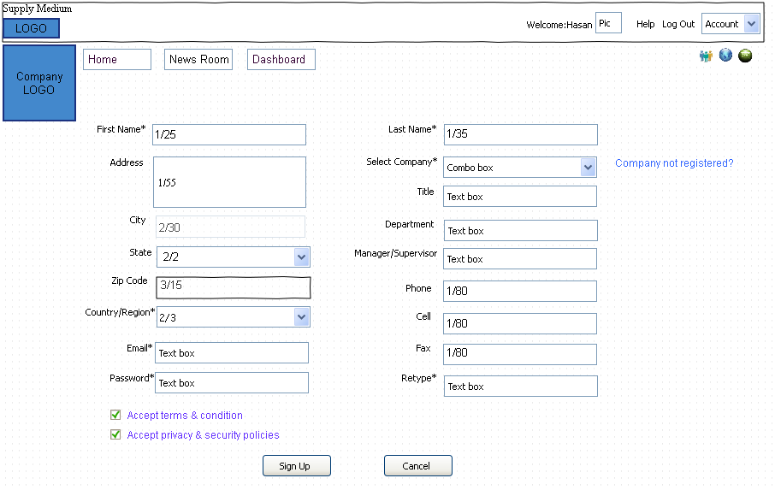

In case the user is send invitation we should include a check box indicating if his address is different from that of the company and if not then address should be populated by default

|  |  |  |  |  |
| --- | --- | --- | --- | --- |
| **User Fields** | **Status** | **Max/Min** | **Type** | **Description** |
| Country/Region | M | 2/3 |  | Code identifying the country. U.S is selected by default. |
| Select Company | M |  |  | The Company/Organization the individual works for. In case the individual is added by the administrator this field will be populated by default. |
| First Name | M | 1/25 |  | Individual first name |
| Last Name | M | 1/35 |  | Individual last name |
| Title | O |  |  | Individual title in the company often used as a means of identifying his/her function in the organization. |
| Address | O | 1/55 |  | Address information |
| City | O | 2/30 |  | Free-form text for city name |
| State | O | 2/2 |  | Code (Standard State/Province) as defined by appropriate government agency |
| Zip | O | 3/15 |  | Code defining international postal zone code excluding punctuation and blanks (zip code for United States) |
| Type | M |  |  |  |
| Email | M |  |  | Individual email. This should be other than the individual email assigned by SupplyMedium. This email address will be used to send the individual username and password when he registers for the first time with SupplySeek. This email address will also be used to email incase the individual forgets his password and a new password is emailed to him. |
|  |  |  |  |  |
| Password | M |  |  | A sequence of characters that one must input to gain access to SupplyMedium. |
| Retype Password | M |  |  |  |
| Department | O |  |  | A business is normally organized by its functions, e.g. marketing department, accounts department and so on. This is because being grouped together allows the functions to benefit from specialization and division of labor. |
| Manager/ Supervisor | O |  |  | The person in the organization the individual reports to. |
| Company Phone | O | 1/80 |  | Office Phone Number |
| Cell | O | 1/80 |  | Cell phone |
| Fax | O | 1/80 |  | Fax Number |

**Admin**

* Admin will have several rights to control account policies, user management, user groups as below

**The administrator can also assign different task to different people. For example he can assign that the P.O goes to a certain person in the organization. Need to discuss.**

**User Management:**

* Admin can create restriction or expiration on specific user(s) <select Users> or specific user group(s) <select User Groups> using the interface below with the options for Restrictions and Account Expiration
* Specific users or User Groups will be selected from the right hand side list box
* For the Users link, Admin will be displayed with a list of users and admin can select one or more users to enforce any account restrictions.
* Admin can also add a new user manually by clicking ‘New’ and he will be taken to User signup interface.
* Admin can create a User Group by clicking on User Group button where he will be taken to User Group interface or setup Department by clicking Department link or button or setup account policies using Account Policies link or update Company Account using Company Account Management interface
* Example:

Name|City|Email|Status|State

User 1|Columbus|user1@xyz.com|Activated|Connected

User 2|New York|user2@xyz.com|Waiting activation|Not Connected

User 3|Columbus|user3@xyz.com|Approval requested|Not Connected

User 4|Columbus|user4@xyz.com|More info requested|Not Connected

User 5|Columbus|user5@xyz.com|Rejected|Not Connected

User Management involves role-based authorization, in which you assign permissions to users and user groups, to manage their access to system level and specific rights.

User Management provides access to the following screens and functions:

* [Users](javascript:void(0);) - create users and assign users to groups
* [User Groups](javascript:void(0);) - create, assign and manage user groups
* [Authentication](http://global.avocent.com/us/olh/trellis/v1.2.0/en/content/admin/usermanag/authentication.htm) - manage user access to resources
* [Account Policies](http://global.avocent.com/us/olh/trellis/v1.2.0/en/content/admin/usermanag/manaccountpolicies.htm) - create user session policies
* [Notifications](http://global.avocent.com/us/olh/trellis/v1.2.0/en/content/modules/site_manager/notifications/notifications.htm) - configure users and resources for notification of events

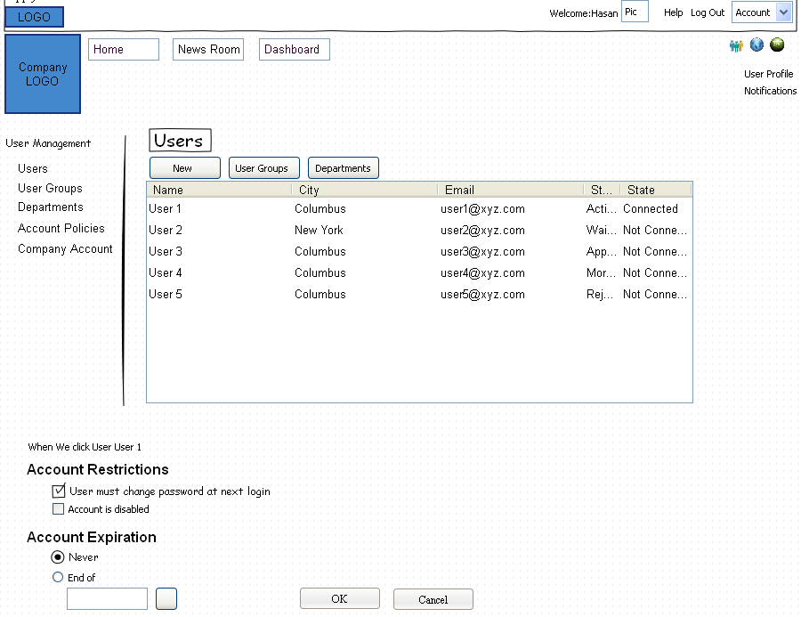

**Users**

This screen allows you to create and edit user details, assign a user to a group, remove a user, end a session and create restrictions for a user.

**To create a user:**

1. Under User Management, click *Users*.
2. Click *New*, then under Create a New User, enter the username and email address. Spaces are not allowed.
3. Click *Save*. An email is sent to the user with a username and password.

**To remove a user:**

Select a user and click *Remove* - *Yes*.

**To end a session:**

Select a user and click *End Session* - *Yes*.

**User Groups:**

* Admin can create a new user group and assign one or more users to that group or modify an existing user group in terms of adding or deleting any users from that group
* Admin can assign additional users or user group to Admin role
* Admin can assign a particular user specific privileges using Privileges using Assign a new user button

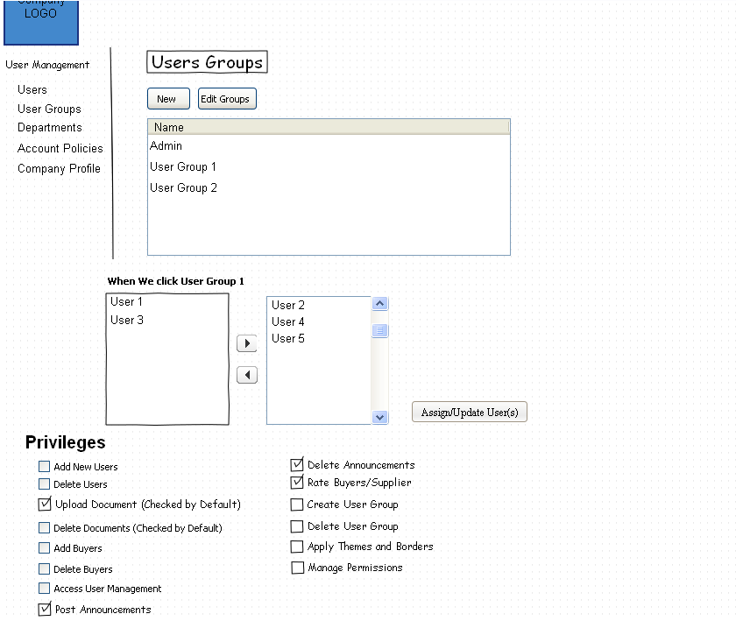

This screen allows you to create new groups and map users to a group.

|  |  |
| --- | --- |
| **This privilege...** | **allows an operator to...** |
| Add New Users | Add new users and Edit user profile |

|  |  |
| --- | --- |
| Delete Users | Delete new users. |
| Access Groups | Access/view user groups |
| Upload Documents (External) | Upload Documents to the Company’s External page |
| Delete Documents (External) | Delete Documents to the Company’s External page |
| Upload Documents (Internal) | Upload Documents to the Company’s Internal (Home) page |
| Delete Documents (Internal) | Delete Documents to the Company’s Internal (Home) page |

|  |  |
| --- | --- |
| Add Buyers | Add Buyers |
| Delete Buyers | Delete Buyers |

|  |  |
| --- | --- |
| Access Users Management | Access/view the User management page. |
| Post Announcements (External) | Post Announcements to the company Company’s External page |
| Delete Announcements (External) | Delete Announcements to the company Company’s External page. |
| Post Announcements (Internal) | Post Announcements to the Company’s Internal (Home) page |
| Delete Announcements(Internal) | Delete Announcements to the Company’s Internal (Home) page |
| Rate Buyers/Suppliers | Rate Buyers and suppliers. |
| Create User Groups | Create new user groups and edit existing user groups |
| Delete User Groups | Delete user groups |
| Apply Themes and Borders | Apply themes and borders to the company’s internal and external page. |
| Manage Permissions | point number, type, range, and network source and destination. |

**Department Setup page**

The admin has the ability to add departments. Once the department is created it will show up in the upper tool bar. Once the department is created the admin can assign user group or individual user to that department. To assign user/user groups to the department highlight the department in the main Department box. In the Assign User group/ User all the User groups and users will be displayed in alphabetical order, with user groups followed by individual users. The admin can assign the user group/user by selecting the User group/user and clicking the  button. To assign folders to the departments highlight the department in the main Department box. In the Add Folders all the Folders will be displayed in alphabetical order, e.g., accounting forms, procurement management etc. The admin can assign the folders by selecting the Folder and clicking the  button. The admin can now assign folders to these user groups. The admin can also assign privileges to different user or user group for that department. The privileges are

Add folders on the department page

Add files to the department page

Delete folders on the department page

Delete files to the department page

Post announcements

Change background color etc

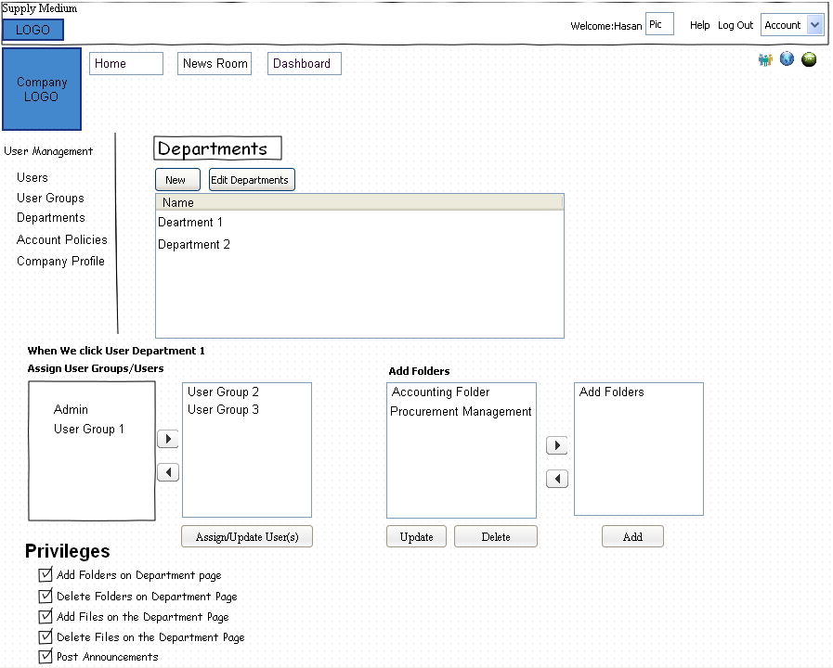

|  |  |
| --- | --- |
| **This privilege...** | **allows an operator to...** |
| Add Folders (Existing) | This will allow the user to add pre-existing folders to the department page. |

|  |  |
| --- | --- |
| Delete Folders (Existing) | This will allow the user to Delete pre-existing folders to the department page. |
| Create New Folders | This will allow the user to create new folders in the department page. |
| Delete Folders | This will allow the user to delete folders created for that specific department. |

|  |  |
| --- | --- |
| Upload Documents | Upload Documents to the Department page. |
| Delete Documents | Delete Documents to the Department page. |

|  |  |
| --- | --- |
| Post Announcements | Post Announcements to the Department page. |
| Delete Announcements | Delete Announcements to the Department page. |
| Apply Themes and Borders | Apply themes and borders to the department page. |

**Account Policies:**

Admin can enforce account policies on specific user(s) <select Users> or specific user group(s) <select User Groups> using the interface below with the options for Account Policies, Account Lockout Policies and Session Management.

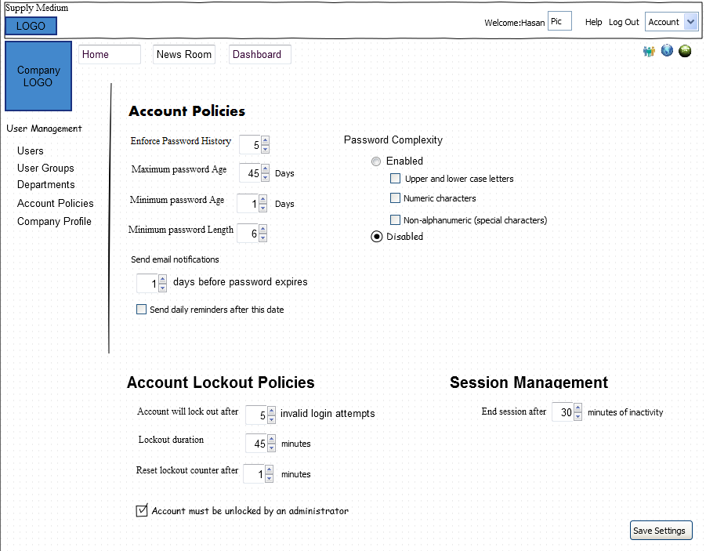

#### Account Policies

The Account Policies screen is used to configure password and session rules for all users. Passwords are auto generated using the local policy for complexity and sent to the user by email or SMS. When the generated password is used to log in, a dialog box opens to reset the password using a string that only the user knows. The following are the default password policy settings:

* Enforce password history = 5 only.
* Maximum password age = 45 days.
* Minimum password age = 1 day.
* Minimum password length = 6 characters.
* Password character complexity, when enabled, allows upper and lower alpha, numeric and special characters.
* Store password using reversible encryption for all users. The default is Off.
* Password expiration notification.

**To set account password policies:**

1. Under User Management, click *Account Policies.*
2. Select the password rules for history, maximum age, minimum age and length.
3. At *Send email notifications*, set the number of days to receive a notification by email before the password expires.
4. Enable or disable the *Send daily reminders after this date* option.
5. Under Complexity, select *Enabled* or *Disabled.*

**NOTE:** If the password is updated before the password is set to expire, the password age is reset.

**To configure account lockout policies:**

1. At the Account Policies screen, under Account Lockout Policies, select:
2. Number of invalid login attempts allowed before lockout.
3. Minutes for lockout duration.
4. Minutes until lockout is reset.
5. Enable or disable the *Account must be unlocked by an administrator* option and click *Save Settings*.

**To end a session:**

At the Account Policies screen, under Session Management, select the required minutes of inactivity before ending a session.

-or-

Click *End All Active Sessions* - *Save Settings* to end all active sessions immediately.

**NOTE:** Password unlock applies to unauthenticated reset as well.

**To auto generate a password using the administrator login:**

1. Under User Management, click *Users* and select a name.
2. Click *Send Password Reset*. The password is sent to the user and a message is sent to the administrator confirming the password was sent to the user.

**Company Account management**

The company account management page is used to manage the company account. Here the admin or users with administrative rights have the ability to change company address and add new addresses. Here the admin can also select the background for the company internal, external and user pages. The admin can limit the user to use the background chosen. The admin can also set the colors for the company pages. He can select different colors for the entire page or have different color schemes selected for different parts of the pages

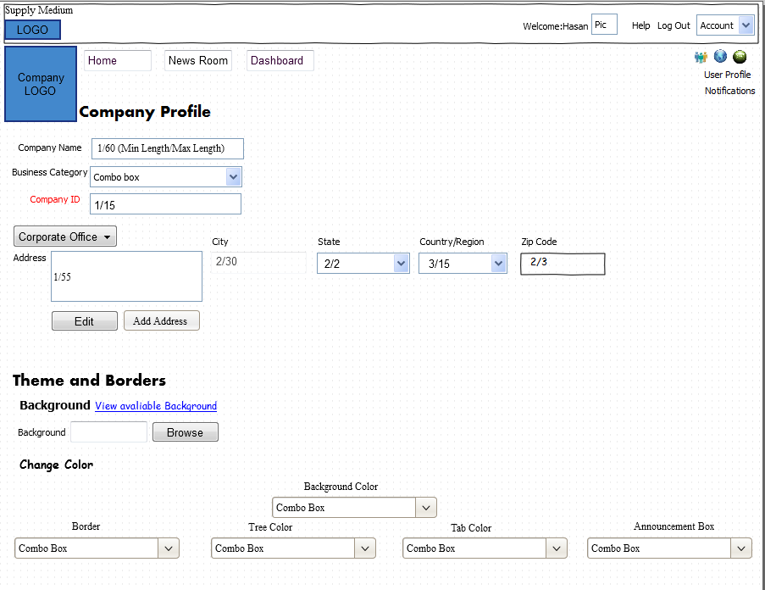**Company External page**

This page will be visible to on the internet. Here the customer will have the ability to customize the page. The customer will have the ability to create customized tabs. He can also select the background color and add photos or videos on the page.

* Any small business user should be able to create an external web site which will be part of SupplyMedium (SM) server visible within SM Application as unique url (http://www.sm.com/xyz) as well as a standalone website (hosted on SM server) for the external world e.g. http://www.xyz.com
* The website can be designed in design time mode and viewed as the finished site in run time mode.
* In design time mode, user will have access to all standard controls to be dropped on the canvas along with series of templates that the user can use for his website

In the Product link, all product SKU’s will be displayed along with the prices

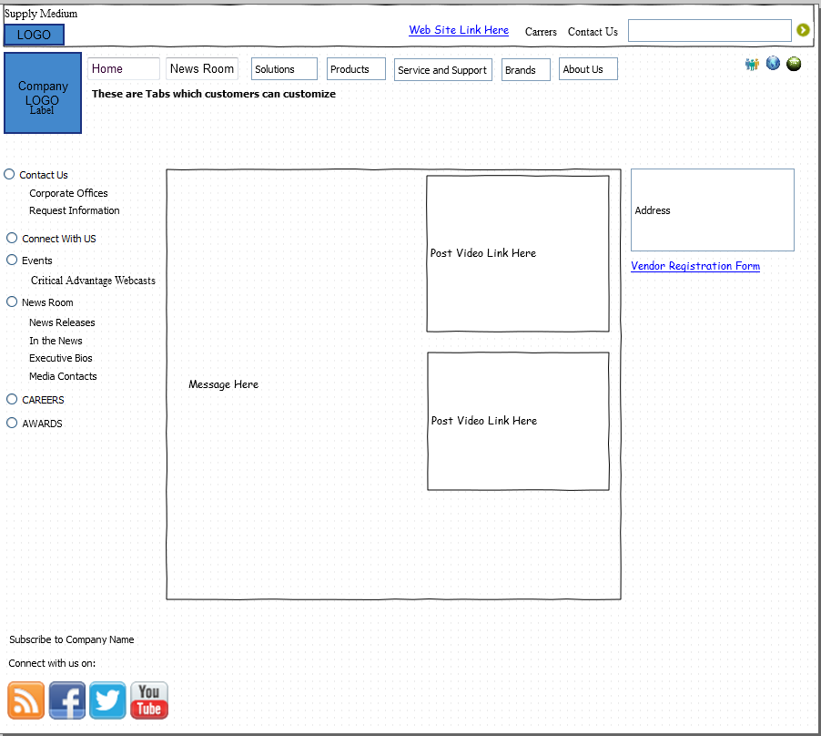

**When user clicks on Products**

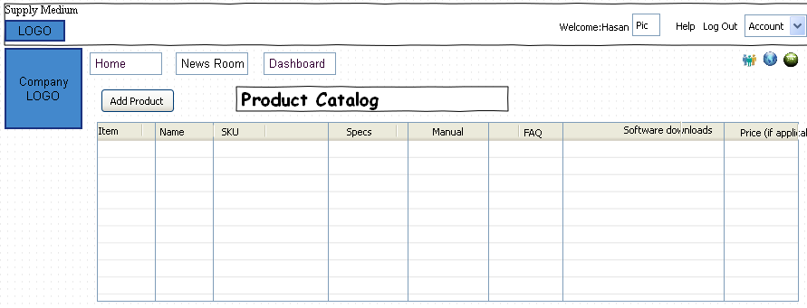**Main Internal Company page**

* The generic layout is applicable across all interfaces with SupplyMedium and its logo on top left and user pic along with help and Account menu items on top right. This Masthead is the same across all UI
* Below the top masthead is a sub-masthead containing specific logo of user’s company on left and 3 icons for new company alert, private message & notifications
* In the middle, there will be links for Home (under company profile or user’s profile), NewsRoom (latest updates as newsfeed) and Dashboard (charts to display company’s health)
* Announcements will be equivalent to an intranet (internal to the company only) so that visibility is specific to internal employees of that company only
* User will be provided a list of recommended buyer/supplier – this will be displayed in the main internal as well as department and individual user which have the privileges to add or delete buyer/supplier. The logic for the recommended buyer/supplier list will be based upon similar category for that particular buyer/supplier in which they are dealing.
* Clicking on ‘1 transaction waiting to be reviewed – Click for Details’ it will take the user to Transaction History to see the pending transactions. This will be also be visible for all employees involved with procurement management with appropriate privileges for buyer/supplier invoice activities etc.
* This page will also contain a recycle Bin folder. In case the user delete any document from the page those will be stored her. They will be store for 30 days and then deleted.
* The user will also have the ability to search items. The search will display all the relevant choices from the company website.

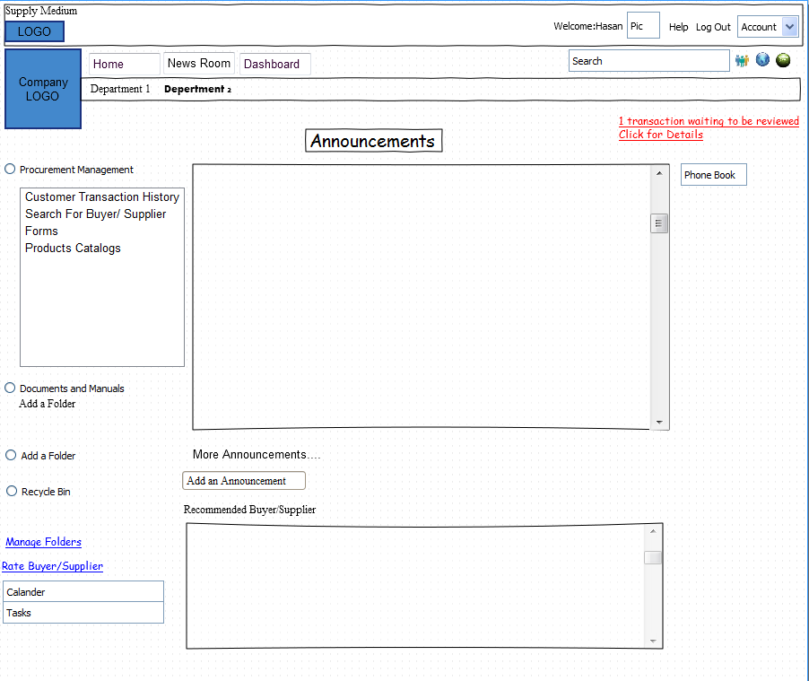

**Department page**

The department page is shown below. The specifications for this page are the same as those for the main internal page with the exception that only authorized user can make changes on this page.

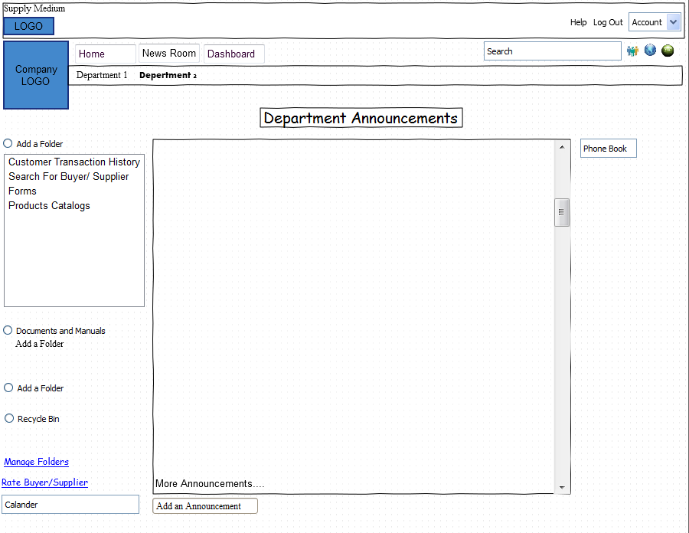

**User Page**

1. Upon registration with the company each user will be assigned his/her own individual page. He can customize this page to suit his/her needs.
2. To add a folder double click “Add a Folder” A pop up window will appear which will ask for the folder name.
3. To add files to the folder right click the folder. Two options
   * Add a Document
   * Delete the folder
4. Clicking the Manage Folder will open another page where all the folders will be listed in the order they are in. You can change the position of the folders.
5. He will be able to view all his feeds/activities in this page and can post any specs

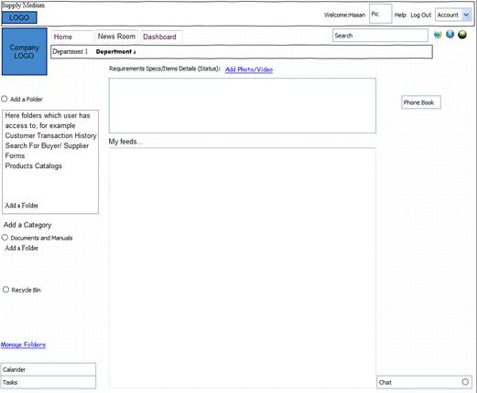

**User Acct Management**

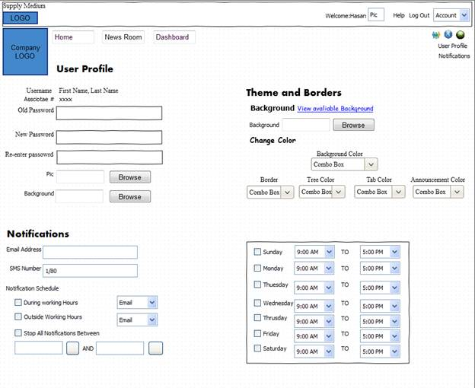

This interface will be used by individual user to

* Manage their account to change password,
* Attach picture to the user page,
* Settings user notifications via email or text
* Setting Theme
* Setting Colors

|  |  |  |  |  |
| --- | --- | --- | --- | --- |
| Command | Status | Max/Min | Type | Description |
| Username |  | 1/80 |  | A user has a **user account** and is identified by a **username** (also **user name**). A user's account allows a user to authenticate to system services and be granted authorization to access them. To log in to an account, a user is typically required to authenticate oneself with a password or other credentials for the purposes of accounting, security, logging, and resource management. |
| Associate Number (Associate#) |  |  |  | Each employee is given a “Associate Number" to uniquely identify each employee. |
| Password |  |  |  | A **password** is a secret word or string of characters that is used for user authentication to prove identity, or for access approval to gain access to a resource. |
| Pic |  |  |  | To attach your picture to your web page:   1. Click Browse and browse to the location where the picture is stored 2. Click Attack |

To change the page background

1. The individual user also has the ability to change the background for the page if this privilege has been given to him by the administrator
2. To select an available theme click “View available Background” It will take you to the page where
3. To upload a new theme click Browse and upload a new picture

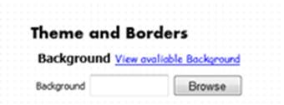

To Change the page color

**Note:** All the company page colors are unique for each login, i.e., each user with a separate login can set his/her own color scheme for his/her page.

To change the background color of individual user page of the entire page we select the color from the “Background Color” drop down menu. Under Background Color there are several color options and custom. **White** is selected by default. To change colors we can either select color from the drop down menu or we can select custom.

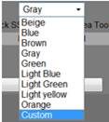

From the color drop down menu under Background Color we can select the color. Here selecting the color will change the color for the web page.

There is also the option to individually select colors for different portions for the web page. To do this we must first change the SCHEME to “Custom” and select the color.



The other options available are:

* + Border
  + Tree Color
  + Tab color
  + Announcement

To change the border color we select the color from the Border Color. In this example we have selected light blue.

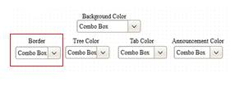

In case the desired color is not available we can select “New”. If “New” is selected a color wheel will become visible where a user can select from 4096 colors in a chromatic scale.

* + The user will have the ability to change the border and the background colors of his page.

Set Notification

This screen is used to enter an email address and SMS number to which notifications will be sent. Email and SMS messages can be sent in Rich Text or Plain Text formats using templates. Scheduling and editing of notifications can also be performed at this screen.

To set email notification

* + Enter the email address in the email address box
* To get email from 9am to 5pm check the “During Working Hours”
* To get after hours, 5pm to 9 am, check Outside Working Hours
  + To stop notifications between a certain hours check “Stop All Notification Between” and select time

To select a specific day of the week and select the day and specify the time you need to get the notifications

To set SMS notifications

* + Enter the SMS number in the SMS box
  + To get email from 9am to 5pm check the “During Working Hours”
  + To get after hours, 5pm to 9 am, check Outside Working Hours
  + To stop notifications between a certain hours check “Stop All Notification Between” and select time

To select a specific day of the week and select the day and specify the time you need to get the notifications

**Flow of information/task between Buyer and Seller business:**

* + Note that in each of the buyer-seller interaction interfaces, information is passed as XML in EDI format

**Search Suppliers:**

The Buyers have the ability to initiate a search for Supplier.

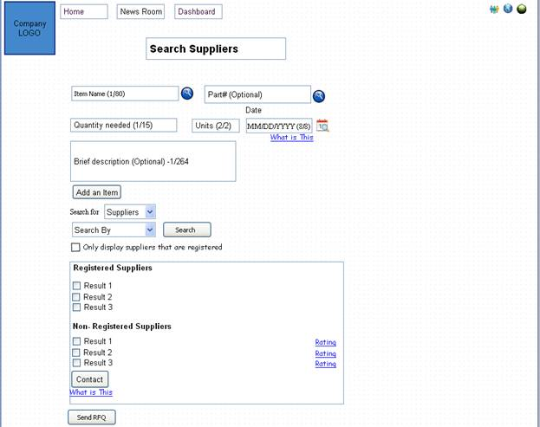

The buyer specifies the item and the quantity required and a cutoff date when he wants the order to be delivered. “Add an Item” button allows the user to add items to the *search*. Search can be filtered based on business categories but that is not a must. Checking “Only display suppliers that are registered” will cause the search results to be limited to suppliers register with the company. If the box is not checked the search result will list both registered and non-registered suppliers but under their own separate heading. As mentioned above the suppliers are separated in two categories, registered and non-registered. Registered suppliers are those that are registered with the company.

Once the buyer initiates a search the results will be displayed. He can select multiple suppliers and press “send RFQ”. A quote will be send to the selected suppliers. In case the seller is unregistered the buyer can select the seller and hit “Contact”. A vendor registration form will be send to the seller/supplier.

**Search Buyers**

The System Settings page contains information that you must enter before SiteScan® Web can run properly.

To access System Settings:

1. On the **CFG** tree, select **System Settings**.
2. Click each tab, then enter the necessary information. Tab details are described below.

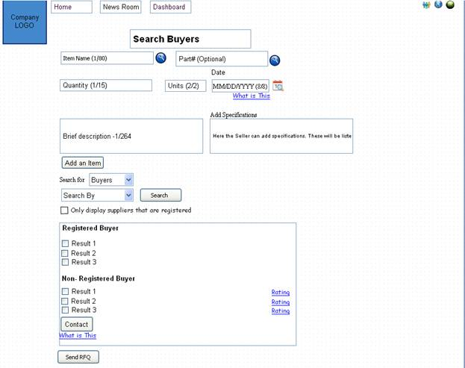

The Supplier has the ability to initiate a search for Buyers.

The supplier specifies the item and the quantity required and a cutoff date when he wants the order to be delivered. “Add an Item” button allows the user to add items to the search. Search can be filtered based on business categories but that is not a must. Checking “Only display suppliers that are registered” will cause the search results to be limited to suppliers register with the company. If the box is not checked the search result will list both registered and non-registered suppliers but under their own separate heading. As mentioned above the suppliers are separated in two categories, registered and non-registered. Registered suppliers are those that are registered with the company.

Once the buyer initiates a search the results will be displayed. He can select multiple suppliers and press “send RFQ”. A quote will be send to the selected suppliers. In case the seller is unregistered the buyer can select the seller and hit “Contact”. A vendor registration form will be send to the seller/supplier

|  |  |  |  |  |
| --- | --- | --- | --- | --- |
| Fields | Status | Max/Min | Type | Description |
| Item Name | M | 1/80 |  | **The Item Name** is a name, especially one legally registered as a trademark, used by a manufacturer or merchant to identify its products distinctively from others of the same type and usually prominently displayed on its goods, in advertising, etc. |
| Part# | O |  |  | A combination of numbers, letters, and symbols assigned by a designer, a manufacturer, or vendor to identify a specific part or item of materiel. |
| Quantity Needed | M | 2/2 |  | Specified number or amount items. |
| Units | M | 1/15 |  | Specifies the units for the items. For example if bags of wheat are ordered then the unit is kilogram (kg) |
| Date | M | 8/8 |  | Specifies the date on which the item is needed. This date can be changed in the P.O or invoice. |
| Brief Description | O | 1/264 |  | The initiator of the quote can add further details about the item or any special instructions. |
| Search for | - | - |  | Select Buyers or Suppliers. Supplier is selected by default. |
| Search By | - | - |  | The user will have the ability to search the based on department categories. This will help user to do targeted searches |
| Registered Buyers |  |  |  | Registered buyers are those that have gone through the registration process, i.e, either added by the administrator or submitting the vendor registration form. To be registered the vendor registration form needs to be approved by the company |
| Non-Registered Buyers |  |  |  | Non registered buyers refer to those companies that have not been registered by the company. (Refer to the Vendor registration on details on how to register). |
| Contact |  |  |  | In case the company is not registered the company initiating the search has the ability to request registration by the other company. The search initiator needs to select the company and then hit Contact. This will send the Vendor registration form to the selected company/companies. |

**Vendor Registration From**

Some companies require that the vendor register with that company as the first step to be considered for participating in tendering exercises.  To register the supplier needs to fill the vendor registration form. This form is available on the main internal page under forms form on the company website. This form is also available on the main external page. This form can also be accessed through the Buyer list wireframe by clicking “Add a Buyer”.

The Vendor Registration Form is displayed below

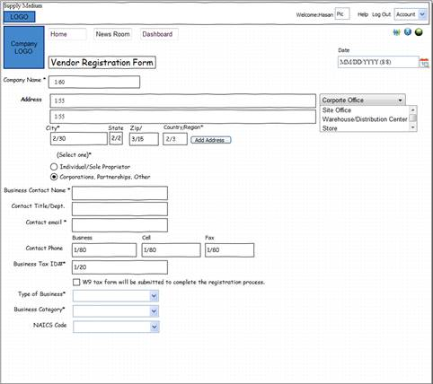

|  |  |  |  |  |
| --- | --- | --- | --- | --- |
| Fields | Status | Max/Min | Type | Description |
| Date | O | 8/8 |  | Date |
| Company name | M | 1/60 |  | Company Name specifies the name of the company applying for registration. |
| Address | O | 1/55 |  | Address information |
| Address Type |  |  |  | The user has the ability to select   * Corporate Office * Site Office * Warehouse/ Distribution Center * Store |
| City | M | 2/30 |  | Free-form text for city name |
| State | O | 2/2 |  | Code (Standard State/Province) as defined by appropriate government agency |
| Zip | O | 2/2 |  | Code defining international postal zone code excluding punctuation and blanks (zip code for United States) |
| Country/Region | M | 2/3 |  | Code identifying the country. U.S is selected by default. |
| Select One | - | - |  | User has to select one of the choices   * Individual/ Sole Proprietor * Corporation, Partnership, Other |
| Business Contact Name | M |  |  | This field specifies the primary contact for the registering firm. All the business correspondence will be directed to that person. The person can assign secondary contact. |
| Contact Title/ Department |  |  |  | Individual title in the company often used as a means of identifying his/her function in the organization. |
| Contact email | M |  |  | Email of the primary contact. All the email from the buyer will go to this email. |
| Contact Phone |  |  |  | Contact phone of the primary contact |
| Business Tax ID | M | 1/20 |  | Federal Tax Identification Number, is also known as an Employer Identification Number (EIN), and is a unique nine-digit number used to identify the tax account of a business entity. An EIN works much like a Social Security number and is offered through the Internal Revenue Service at no cost. |
| Type of Business |  |  |  | Disconnects you from a BACnet dial-up session if you are the last active operator. |
| Business Category |  |  |  | These types of businesses are: (1) Sole Proprietorship, (2) Corporation, and (3) Limited Liability Company. |
| NAICS Code | O | 6/6 |  | The North American Industry Classification System (NAICS) code is a six-digit code that represents types of industries. The NAICS has been designed as the index for statistical reporting of all economic activities of the U.S., Canada, and Mexico. |

In case the user selects USA as the country, another interface will be displayed as these laws are specific to USA.

If the user is from non USA country, then additional details section will become part of the above interface.

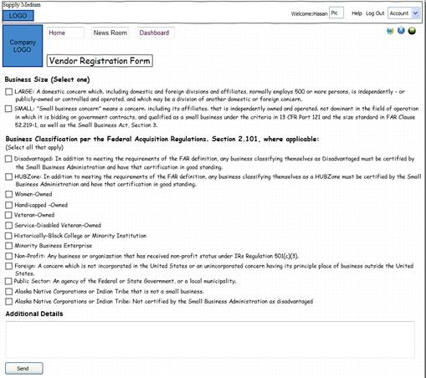

W9 tax form will be submitted to complete the registration process: Some companies in the US require that the supplier submit the W9 tax form before they can be registered to do business with that company. However, this will be an optional field. In case this field is not checked by the buyer it will not be displayed to the customer and that information will not be requested. If checked this information will be required form all companies that register. This will be one of the options that can be set in the template.

**Vendor Registration Form Acceptance**

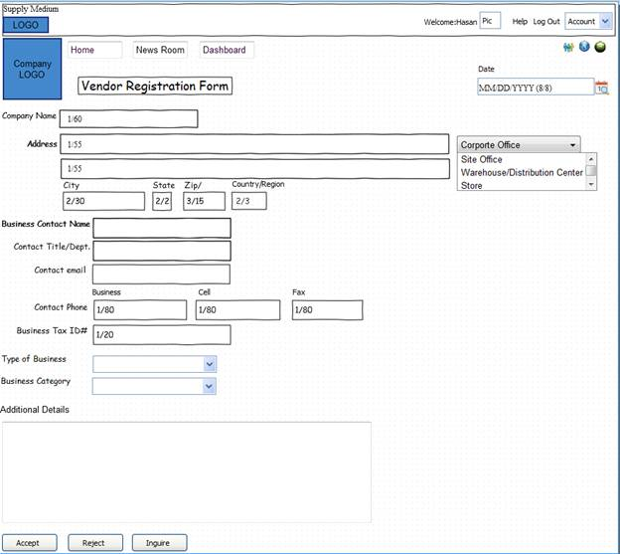

Once the buyer gets the form the completed form he has the ability to accept, reject or ask for additional information. In case the vendor is accepted he will be send an email indicating that he has been registered as a valid seller with the company. The vendor will also appear in the Buyers list section. The Buyer can also request additional information.

**Request for Quote**

*A* ***request for quotation*** *(****RFQ****) is a standard business process whose purpose is to invite suppliers into a bidding process to bid on specific products or services. An RFQ typically involves more than the price per item, however, in our case the prime function of the process will involve price. . Information like payment terms, quality level per item or contract length are possible to be requested during the bidding process.*

Request for Quote can be generated in two ways

* + As explained earlier the buyer can do a search and ask for a quote
  + Contact a seller directly for a quote using the request for quote template.

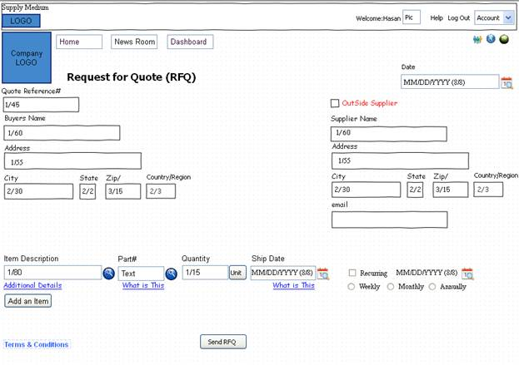

The buyer can also go on this page and fill in the details manually to send a quote. Here he has the option to send the quote to people who are not registered with SupplyMedium. To send quote to people outside he needs to check the box “Outside supplier”. This box will be unchecked by default. Once checked an email box will be displayed. The buyer can then put the email address of the seller and send the quote. In this case they will have a pop up box’ The Seller is not registered with SupplyMedium. Do you want to add the seller to your Buyers list”. Once the buyer clicks yes, the seller will be added to the buyers list of the buyer and an invitation email send to the supplier to join SupplyMedium.

|  |  |  |  |  |
| --- | --- | --- | --- | --- |
| Fields | Status | Max/Min | Type | Description |
| Date | M | 8/8 |  | Date Request for Quote (RFQ) is issued |
| Request For Quote (RFQ) Reference Number | M | 1/45 |  | Your Request for Quote Reference Number is a unique number that is assigned to each new quote. It is an ID number used to track and verify an issued estimate or quote.  This number will start with the prefix RFQ. |
| Outside Suppliers | - | - |  | In case the outside supplier is checked the user can generate quote to a company/organization that is not registered with SupplyMedium. If this box is checked an email box will appear. Filling this email box with a valid email address is mandatory for such quotes. |
| Buyers name | M | 1/60 |  | Buyers name |
| Suppliers Name | M | 1/60 |  | Supplier name |
| Address |  | 1/55 |  | Address information |
| City |  | 2/30 |  | Free-form text for city name |
| State |  | 2/2 |  | Code (Standard State/Province) as defined by appropriate government agency |
| Zip |  | 3/15 |  | Code defining international postal zone code excluding punctuation and blanks (zip code for United States) |
| Country/Region |  | 2/3 |  | Code identifying the country. U.S is selected by default. |
| Item Name | M | 1/80 |  | **The Item Name** is a name, especially one legally registered as a trademark, used by a manufacturer or merchant to identify its products distinctively from others of the same type and usually prominently displayed on its goods, in advertising, etc |
| Part# | O |  |  | A combination of numbers, letters, and symbols assigned by a designer, a manufacturer, or vendor to identify a specific part or item of materiel. |
| Quantity Needed | M | 1/15 |  | Specified number or amount items. |
| Ship Date | M | 8/8 |  | Specifies the date on which the item is needed. This date can be changed in the P.O or invoice. |
| Recurring |  |  |  | DO we need recurring here |

Once the buyers send the request for quote the seller is notified in the following ways

* 1. A quote is send to the primary email account listed. The seller can view the RFQ and respond to it via email. A pdf copy is also attached with the message is send to the primary email
  2. In the page of the person who have the privileges to view the message an alert is displayed that indicate that he has a quote waiting to be review
  3. The quote is also saved in the Buyers list column under the name of that customer.

**Note: Terms & Conditions is a clickable attachment that the buyer can add to RFQ to detail out their terms and conditions for the transaction.**

**Quote:**

The seller then responds to the quote.

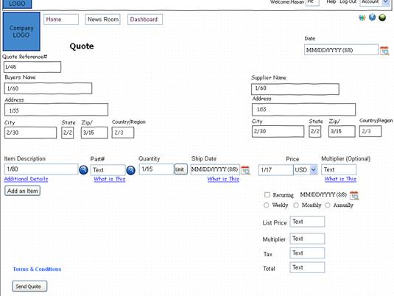

|  |  |  |  |  |
| --- | --- | --- | --- | --- |
| Field | Status | Max/Min | Type | Description |
| Date | M | 8/8 |  | Date Quote is issued |
| Quote Reference Number | M | 1/45 |  | Your Quote Reference Number is a unique number that is assigned to each new quote. It is an ID number used to track and verify an issued estimate or quote.  This number will start with the prefix Q and have numbers same as that for the request for Quote (RFQ). |
| Buyers name | M | 1/60 |  | Buyers name |
| Suppliers Name | M | 1/60 |  | Supplier name |
| Address |  | 1/55 |  | Address information |
| City |  | 2/30 |  | Free-form text for city name |
| State |  | 2/2 |  | Code (Standard State/Province) as defined by appropriate government agency |
| Zip |  | 3/15 |  | Code defining international postal zone code excluding punctuation and blanks (zip code for United States) |
| Country/Region | M | 2/3 |  | Code identifying the country. U.S is selected by default. |
| Item Name | M | 1/80 |  | **The Item Name** is a name, especially one legally registered as a trademark, used by a manufacturer or merchant to identify its products distinctively from others of the same type and usually prominently displayed on its goods, in advertising, etc |
| Part# | O |  |  | A combination of numbers, letters, and symbols assigned by a designer, a manufacturer, or vendor to identify a specific part or item of materiel. |
| Quantity Needed | M | 1/15 |  | Specified number or amount items  Quantity that he can supply if lowers than that the indicated in the RFQ. Here he can add details of the reason for this reduced amount and when he can supply, if possible, the rest of the items |
| Ship Date | M | 8/8 |  | Specifies the date on which the item is needed. This date can be changed in the P.O or invoice. |
| Price | M | 1/17 |  | Item price |
| Currency |  |  |  | Currency used for the quote |
| Multiplier |  |  |  | The user has the ability to apply a multiplier for each item. The multiplier is used to discount the price of an item. For example consider that the price of an item is $100. In case a multiplier of 0.6 is used then the price will be reduced to $60. Typically the range is 0.1 to 1 however; higher multipliers can also be used. The default value is 1.  In case the user does use multiplier of individual items he can apply a multiplier on the list price. This will discount the list price by the function of the multiplier.  This information will not be send to the Buyer |
| Recurring |  |  |  | DO we need recurring here |
| List Price |  |  |  | Total of all the item prices without the multiplier. |
| Tax |  |  |  | Tax percentage applicable |
| Total |  |  |  | Quote total taking into account any multiplier used. This will be the amount that the customer needs to pay. |

This can be done in the following ways

* 1. In the email he will have the option to either reject the quote or accept the quote.

Responding to the RFQ assumes that the supplier agrees to the deadline set by the buyers. In case he changes the deadline he must explain why he changed the deadline and when the buyer receives the quote the date will be in red with a message indicating the deadline date has been change

**Quote Acknowledgement:**

Once the buyer receives the quote send by the seller he can review the quote and can either accept, reject or ask for more information. In case he accepts/rejects the quote the seller will receive acknowledgement that he quote had been accepted/rejected by the buyer.

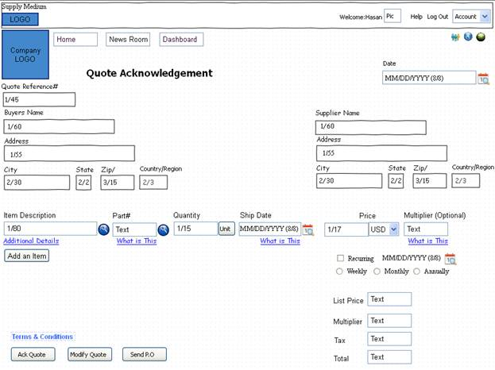

**PO/Quote Accepted**

*A* ***purchase order (PO)*** *is a commercial document issued by a buyer to a seller, indicating types, quantities, and agreed prices for products or services the seller will provide to the buyer. Sending a purchase order to a supplier constitutes a legal offer to buy products or services. Acceptance of a purchase order by a seller usually forms a contract between the buyer and seller, so no contract exists until the purchase order is accepted. It is used to control the purchasing of products and services from external suppliers.*

In case the quote is accepted by the buyer will be prompted that system is ready to generate a P.O. The P.O can be generated in two ways.

* 1. In the email that the buyer accepts the quote he also has the option generate a P.O. Once he clicks P.O a purchase Order will be send to the supplier.
  2. A P.O can also be generated manually in SupplyMedium. The P.O can be send to members of SupplyMedium or nonmembers. In case the recipient of the P.O is a non-member the buyer needs to check the box “Outside supplier”. This box will be unchecked by default. Once checked an email box will be displayed. The buyer can then put the email address of the seller and send the P.O. In this case they will have a pop up box’ The Seller is not registered with SupplyMedium. Do you want to add the seller to your Buyers list”. Once the buyer clicks yes, the seller will be added to the buyers list of the buyer and an invitation email send to the supplier to join SupplyMedium.

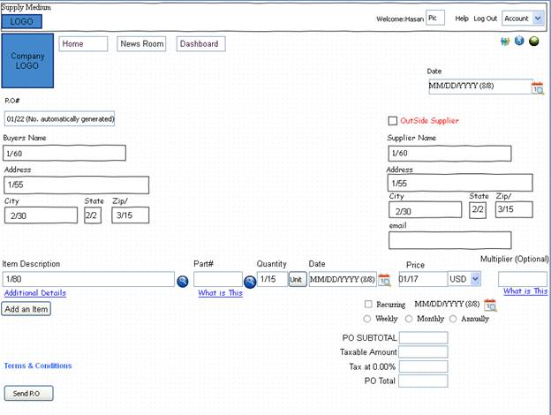

|  |  |  |  |  |
| --- | --- | --- | --- | --- |
| Command | Status | Max/Min | Type | Description |
| Date | M | 8/8 |  | Date P.O is issued |
| P.O Number | M | 1/22 |  | Identifying number for Purchase Order assigned by the buyer/purchaser. The number is used to approve, track and process purchased items.  This number will start with the prefix PO and have numbers same as that for the Quote. |
| Outside Supplier |  |  |  | In case the outside supplier is checked the user can generate P.O to a company/organization that is not registered with SupplyMedium. If this box is checked an email box will appear. Filling this email box with a valid email address is mandatory for such P.O. |
| Buyers name | M | 1/60 |  | Buyers name |
| Suppliers Name | M | 1/60 |  | Supplier name |
| Address |  | 1/55 |  | Address information |
| City |  | 2/30 |  | Free-form text for city name |
| State |  | 2/2 |  | Code (Standard State/Province) as defined by appropriate government agency |
| Zip |  | 3/15 |  | Code defining international postal zone code excluding punctuation and blanks (zip code for United States) |
| Country/Region |  | 2/3 |  | Code identifying the country. U.S is selected by default. |
| Item Name | M | 1/80 |  | **The Item Name** is a name, especially one legally registered as a trademark, used by a manufacturer or merchant to identify its products distinctively from others of the same type and usually prominently displayed on its goods, in advertising, etc |
| Part# | O |  |  | A combination of numbers, letters, and symbols assigned by a designer, a manufacturer, or vendor to identify a specific part or item of materiel. |
| Quantity | M | 1/15 |  | Specified number or amount items.. |
| Date | M | 8/8 |  | Specifies the date on which the item is needed. |
| Price | M | 1/17 |  | Item price |
| Currency | M |  |  | Currency used for the quote |
| Multiplier |  |  |  | The user has the ability to apply a multiplier for each item. The multiplier is used to discount the price of an item. For example consider that the price of an item is $100. In case a multiplier of 0.6 is used then the price will be reduced to $60. Typically the range is 0.1 to 1 however; higher multipliers can also be used. The default value is 1.  In case the user does use multiplier of individual items he can apply a multiplier on the list price. This will discount the list price by the function of the multiplier. |
| Recurring |  |  |  | By checking recurring the customer can schedule automatic P.O to be issued at specific interval. |
| P.O SUBTOTAL |  |  |  | Total of all the item prices without the multiplier. |
| Taxable amount |  |  |  | Total amount of taxes |
| Tax at 0.00% |  |  |  | Tax percentage applicable |
| P.O Total |  |  |  | P.O total taking into account any multiplier used. This will be the amount that the customer needs to pay. |
| Term & Condition |  |  |  | When the user clicks this link a pop up window will appear. Here the user can copy and paste their company’s P.O term and conditions. |

**PO ACKNOWLEGEDMENT/ CHANGE**

When the seller receives the P.O he can accept, reject or modify the P.O. In case the P.O is accepted/rejected the buyer will receive acknowledgement that he P.O has been accepted/rejected by the seller. In case the P.O is accepted it is saved as a pdf and an xml file in the transition history of the company.

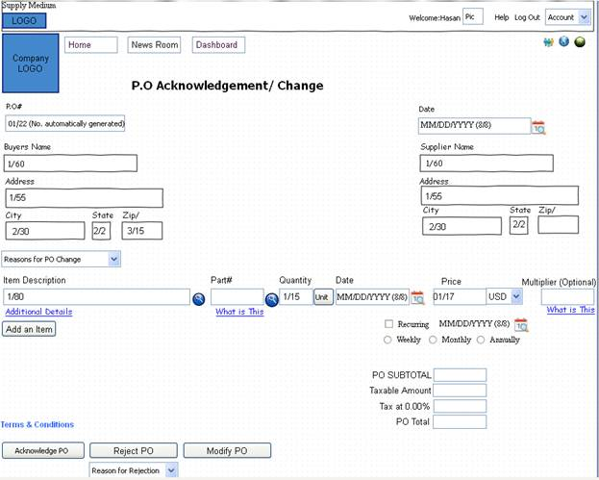

The buyer will use the Modify P.O option to send only the information (segments) that is pertinent to the change to the original order. The original P.O number and/or line item change being requested will always be sent. Change Orders are issued if:

* To add or delete an item or items on a Purchase Order.
* To change the ending dates on a blanket order.
* To change the description of an item(s).
* To change price(s) and/or item(s) if the order total changes by $100 or more.
* Per vendor request with consultation of the user department.
* To change an order to/from positive approval (to approve invoices prior to payment).

**INVOICE**

*An* ***invoice*** *or* ***bill*** *is a commercial document issued by a seller to the buyer, indicating the products, quantities, and agreed prices for products or services the seller has provided the buyer. An invoice indicates the sale transaction only. Payment terms are independent of the invoice and are negotiated by the buyer and the seller. Payment terms are usually included on the invoice. The buyer could have already paid for the products or services listed on the invoice. Buyer can also have a maximum number of days in which to pay for these goods and is sometimes offered a discount if paid before the due date.*

Invoice can be generated in two ways.

* 1. In the P.O email there is an option for the seller to generate an invoice once the P.O has been accepted.
  2. Invoice can also be generated manually in SupplyMedium. This procedure will be used to generate non P.O invoices. The Invoice can be send to members of SupplyMedium or nonmembers. In case the recipient of the Invoice is a non-member the buyer needs to check the box “Outside supplier”. This box will be unchecked by default. Once checked an email box will be displayed. The buyer can then put the email address of the seller and send the Invoice. In this case they will have a pop up box’ The Seller is not registered with SupplyMedium. Do you want to add the seller to your Buyers list”. Once the buyer clicks yes, the seller will be added to the buyers list of the buyer and an invitation email send to the supplier to join SupplyMedium.

Note: In case of a Non P.O invoice the email address of the requester must be included.

**Note: Terms & Conditions is a clickable attachment that the seller can add to Invoice to detail out their terms and conditions for the transaction.**

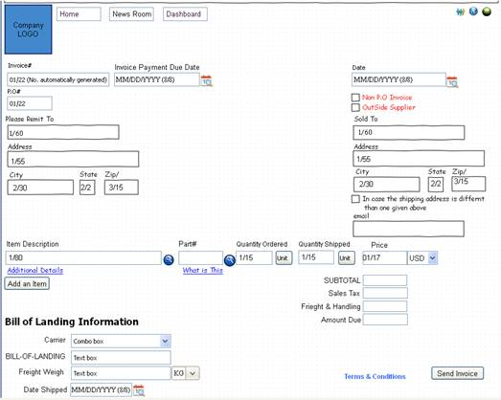

In case the Non-P.O invoice is checked the PO# field will disappear.

|  |  |  |  |  |
| --- | --- | --- | --- | --- |
| Fields | Status | Max/Min | Type | Description |
| Date | M | 8/8 |  | Date Invoice is issued |
| Invoice# | M | 1/22 |  | A unique identification value assigned to a transaction by a merchant, which may be associated with order fulfillment and billing for a transaction. The number is used to approve, track and process invoiced items.  This number will start with the prefix I and have numbers same as that for the P.O |
| Invoice Payment Due Date | M | 8/8 |  | Specifies the date on which invoice payment is due. |
| P.O Number | O | 1/22 |  | Identifying number for Purchase Order assigned by the buyer/purchaser. The number is used to approve, track and process purchased items.  This number will start with the prefix PO and have numbers same as that for the Quote. |
| Non P.O Invoice | - | - |  | In case the Non P.O Invoice is checked the user can generate invoice to a company/organization that is either not registered with SupplyMedium or for which no P.O exists. If this box is checked an email box will appear. Filling this email box with a valid email address is mandatory for such invoices. |
| Outside Supplier | - | - |  | In case the outside supplier is checked the user can generate quote to a company/organization that is not registered with SupplyMedium. If this box is checked an email box will appear. Filling this email box with a valid email address is mandatory for such quotes. |
| Please Remit To | M | 1/60 |  | Supplier name |
| Sold To | M | 1/60 |  | Buyers name |
| Address |  | 1/55 |  | Address information |
| City |  | 2/30 |  | Free-form text for city name |
| State |  | 2/2 |  | Code (Standard State/Province) as defined by appropriate government agency |
| Zip |  | 3/15 |  | Code defining international postal zone code excluding punctuation and blanks (zip code for United States) |
| Country/Region | M | 2/3 |  | Code identifying the country. U.S is selected by default. |
| Item Name | M | 1/80 |  | **The Item Name** is a name, especially one legally registered as a trademark, used by a manufacturer or merchant to identify its products distinctively from others of the same type and usually prominently displayed on its goods, in advertising, etc |
| Part# | O |  |  | A combination of numbers, letters, and symbols assigned by a designer, a manufacturer, or vendor to identify a specific part or item of materiel. |
| Quantity | M | 1/15 |  | Specified number or amount items. |
| Quantity Ordered | M | 8/8 |  | Total quantity ordered |
| Quantity Shipped | M | 1/15 |  | Total quantity shipped |
| Price | M | 1/17 |  | Item price |
| Currency |  |  |  | Currency used for the quote |
| SUBTOTAL |  |  |  | Total of all the item prices without the multiplier. |
| Sales tax |  |  |  | Sales Tax percentage applicable |
| Freight & Handling |  |  |  | Freight & Handling charges |
| Amount Due |  |  |  | Amount Due |
| Carrier |  |  |  | Freight company |
| BILL_OF_LANDING |  |  |  | Bill of Lading is the official document prepared by the carrier duly accepting the goods for shipment containing information like item, quantity, value, vessel details, date, port, consigner, consignee etc. Bill of lading is a contract to carry the goods to the said destination based on which seller can claim consideration and buyer can take delivery of the goods. |
| Freight Weight |  |  |  | Weight of the freight |
| Units |  |  |  | Specified number or amount items. |
| Date Shipped | M | 8/8 |  | Date items are shipped |
| Term & Conditions |  |  |  | When the user clicks this link a pop up window will appear. Here the user can copy and paste their company’s Invoice term and conditions. |

**INVOICE ACKNOWLEGEDMENT/ CHANGE**

The Buyer can acknowledge the invoice or reject it. In case the buyer rejects an invoice he must specify the reasons for rejection. The list of reasons for which an invoice can be rejected are given below.

**Purchase Order number consists of invalid values** – The purchase order number is incorrect. It could be missing, contain all zeros or contain alpha characters.

**Amount invoiced as zero**

**Invoice amount does not total detail amount** – The line items do not add up to total.

**Invoice number not provided**

**Date shipped not a valid date** –It could be an invalid date or a date before the purchase order date.

**Duplicate vendor/invoice from vendor** – We have received this invoice number before. Invoice numbers cannot be recycled for 24 months. You will need to change the invoice number and retransmit.

**Invoice has been set to pay** – The invoice has previously been received and accepted by payables. It is in the system for payment and should be paid accordingly.

**Invoice previously paid** – Company has received and paid an invoice with the same invoice number in the past 24 months for your company. If you feel you have received this message in error, you will need to verify the invoice number.

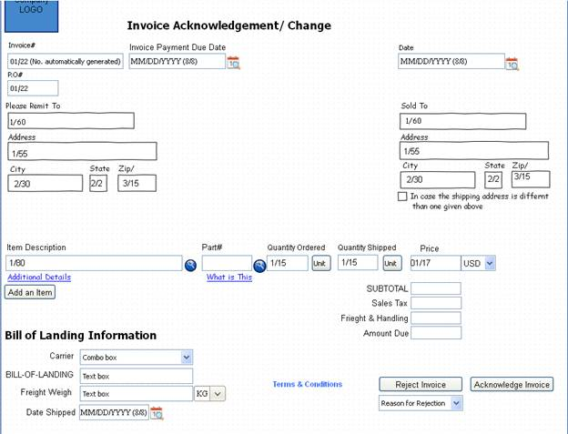

**Customer Transaction History:**

* Customer transaction history is saved in a tabular list
* History will provide a clickable link to past transactions with that supplier or buyer
* Clicking “Add Buyer” will take the user to the “Vendor Registration form”
* There are various fields in the table.
* Clicking the transaction hyperlink will take the user to that specific transaction e.g. clicking on PO would take them to PO Ack since PO has already been issued and is ready for acknowledgement or changes.

|  |  |
| --- | --- |
| Fields | Description |
| Customer ID | Unique ID created by the Company when it adds buyer/Supplier. For example the company XYZ adds a buyer/supplier. This new buyer supplier will be assigned a unique ID. This will help the company to easily identify their customers. |
| Name | Company Name |
| Address | Address information |
| Contact Info. | Will have the email address of the primary contact. Clicking the email address will open an blank email |
| History | Transaction History. The table will display the most recent transaction. Clicking on this will take the user to the user to the customer history page |
| Update | Here the user can add updates, like thing to do. These will be messages/reminders |
| Documents | The user can attach documents to the Customer history page. The top most documents in the queue will be shown here. |
| Rating | This column will display the overall rating of the customer based on all the transactions. |

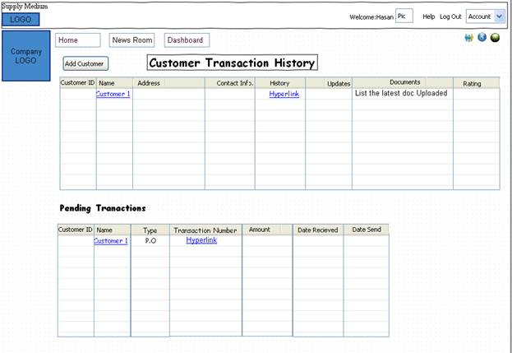

**Pending Transactions**

|  |  |
| --- | --- |
| Fields | Description |
| Customer ID | Unique ID created by the Company when it adds buyer/Supplier. For example the company XYZ adds a buyer/supplier. This new buyer supplier will be assigned a unique ID. This will help the company to easily identify their customers |
| Name | Company Name |
| Address | Address information |
| Type | Type of transaction, for example, P.O, invoice, etc |
| Transaction Number | Transaction number for the transaction, for example, P.O#, Invoice# et c. |
| Amount | Total transaction amount |
| Date Received | Date the transaction is received |
| Date send |  |

**Customer History**

* Clicking the column of history takes the user to the details of the buyer
* In case of multiple addresses the user can add addresses by clicking the “Add Address” button. Each address will be assigned a different customer ID number. In case of multiple addresses the addresses will be shown in a tabular form.

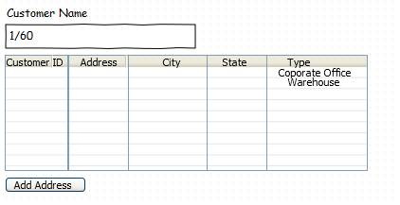

|  |  |  |  |  |
| --- | --- | --- | --- | --- |
| Fields | Status | Max/Min | Type | Description |
| Customer Name |  | 1/80 |  | Customer Name |
| Customer ID |  |  |  | A unique identifier designating the company. |
| Address |  |  |  | Address information |
| City |  |  |  | Free-form text for city name |
| State |  |  |  | Code (Standard State/Province) as defined by appropriate government agency |
| Type |  |  |  | The type specify the location type   * Corporate Office * Site Office * Warehouse/ Distribution Center * Store |

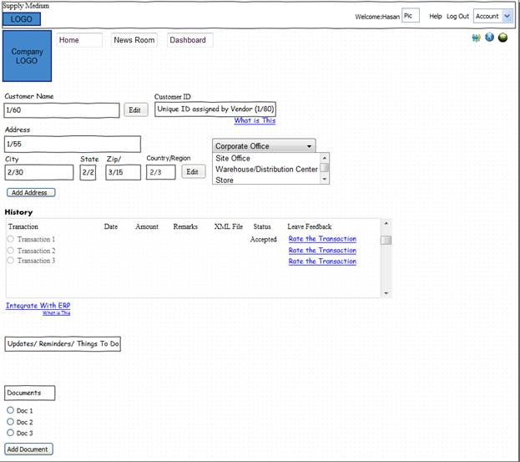

* Updates/Reminders/things to Do.: These are messages that the user can add as reminders. Once the message time is due he will get an alert
* Documents: Here the user can attach documents that are specific to that user. He can also change the oder so that he can make the document added lat as fist which will be displayed in the customer transaction history page.

|  |  |  |  |  |
| --- | --- | --- | --- | --- |
| Fields | Status | Max/Min | Type | Description |
| Customer Name |  | 1/80 |  | Customer Name |
| Customer ID |  |  |  | A unique identifier designating the company. |
| Address |  |  |  | Address information |
| City |  |  |  | Free-form text for city name |
| State |  |  |  | Code (Standard State/Province) as defined by appropriate government agency |
| Zip |  |  |  | Code defining international postal zone code excluding punctuation and blanks (zip code for United States) |
| Country/Region |  |  |  | Code identifying the country. U.S is selected by default. |
| Office Type |  |  |  | The type specify the location type   * Corporate Office * Site Office * Warehouse/ Distribution Center * Store |
| Integrate with ERP |  |  |  | This link gives the user the path of the folder where the EDI files are stored in the SupplyMedium server for that company. The folder is arranged by date where the customer can log in and download the EDI files |

**History**

|  |  |  |  |  |
| --- | --- | --- | --- | --- |
| Transaction |  |  |  | Customer Transaction History |
| Date |  |  |  | Date of the transaction |
| Amount |  |  |  | Total transaction amount |
| Remarks |  |  |  |  |
| XML File |  |  |  | The EDI XML file of the transaction |
| Status |  |  |  | Status of the transaction   * Approved * Rejected |
| Leave Feedback |  |  |  | Clicking the leave feedback link takes the user to the Rate Buyer/Suppler page where he can rate the transaction. |

**Product & Price Catalog**

* Sellers need to provide an interface where any buyers navigating to their site can check out details of their products and price information
* If the product details are stored in an excel or xml or txt file etc, they should be able to retrieve that information to populate the interface in a List
* If the product details info is stored in a database table, seller should be able to connect to the backend to retrieve the data and display in a List
* User should be able to map a SKU to an item and submit it to add to database
* Once the product details have been retrieved from file or database, user can click on View Catalog to view all the product details.

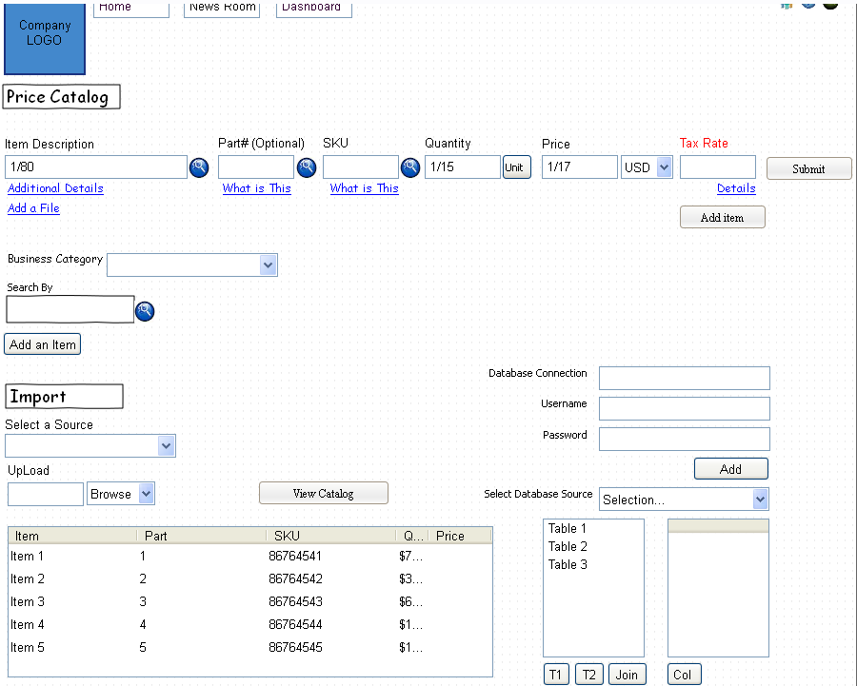

|  |  |  |  |  |
| --- | --- | --- | --- | --- |
| Fields | Status | Max/Min | Type | Description |
| Item Name | M | 1/80 |  | **The Item Name** is a name, especially one legally registered as a trademark, used by a manufacturer or merchant to identify its products distinctively from others of the same type and usually prominently displayed on its goods, in advertising, etc. |
| Part# | O |  |  | A combination of numbers, letters, and symbols assigned by a designer, a manufacturer, or vendor to identify a specific part or item of materiel. |
| SKU | - | - |  | A **stock-keeping unit** or **SKU** is a unique identifier for each distinct product and service. A SKU is a number or string of alpha and numeric characters that uniquely identify a product. The usage of SKU is rooted in data management, enabling the company to systematically track its inventory or product availability, such as in warehouses and retail outlets. |
| Quantity Needed | M | 2/2 |  | Specified number or amount items. |
| Price | M | 1/17 |  | Item price |
| Currency |  |  |  | Currency used |
| Tax rate | M | 2/2 |  | Tax percentage applicable |
| Business Category | M | - |  | A basic category of business activity. The term is sometimes used to describe a very precise business activity (e.g. semiconductors) or a more generic business activity (e.g. consumer durables). |
| Select the Source | - | - |  | Database source. |
| Upload | - | - |  | Upload a file |
| Database Connection | - | - |  | Specify the kind of database connection |
| Username | - | - |  | Username to login into the remote database |
| Password |  |  |  | Password to login into the remote database |
| Select Database Source |  |  |  | Database source   * Access * MySQL |

**Newsroom**

* This is similar to newsfeed of facebook or updates of linkedin where users will see others RFP’s (of buyers) or if Sellers want to reduce their inventory, they can release publicly product specs they wish to sell to buyers
* Buyers can release their RFP/RFQ or Seller their product specs along with attachments for photo, video, word doc, pdf, excel etc. Note that word and pdf attachment support is important since in the specs RFQ, only basic details can be provided but the details of the request can only be provided in an attachment.
* Sellers can similarly provide details of their inventory products specs as public status for buyers to send out PO
* Buyers and Sellers can keep a watch list of their favorite vendors for easy access by clicking on Fav vendors and adding from the list of vendors to fav list (similar to how ‘close friends’ work in facebook) – any new activities (e.g. new RFP of a fav buyer etc) should be alerted as a notification on top right icon.
* Users can create Groups, Events, Notes, Subscriptions similar to facebook – interfaces explained later

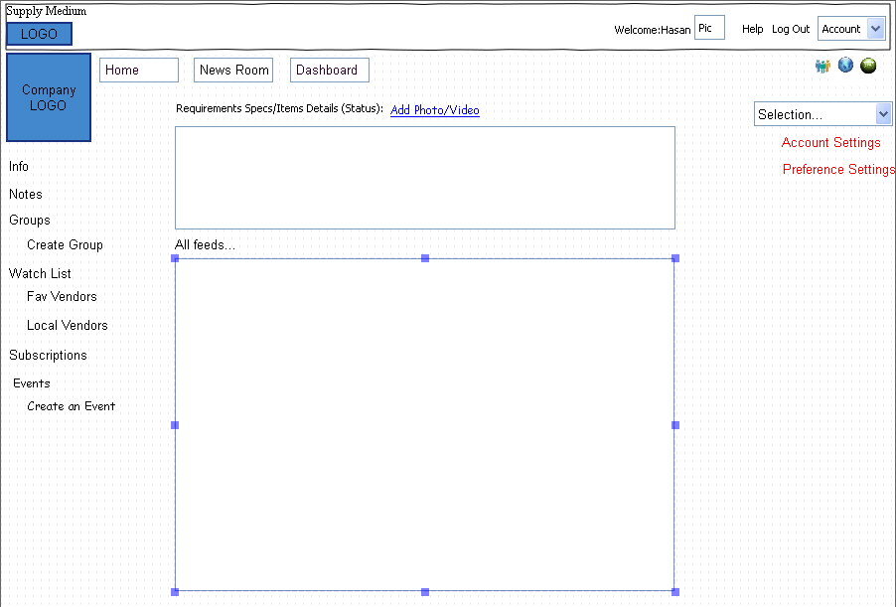

**Dashboard**

* This interface will contain basic ‘at-a-glance’ performance of the company using graphs and charts so that user can get a quick overview of the company health financially and other aspects like inventory, sales, revenue etc.
* User can request a pie chart or a bar chart
* There will be some standard reports available based on tables present in the database

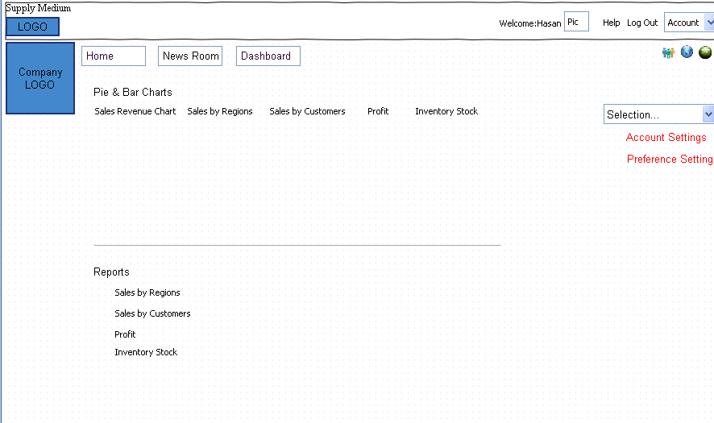

**Messages**

* Private messages will be part of the inbox feature for any communications that user doesn’t want to be public
* Any new private message will alert the user with an incremented message counter on the middle icon on far right side. Clicking on the message will take the user to the actual message
* The format of the message display is shown below with company logo and user pic for each of the messages.
* The layout and style are quite similar to facebook private message inbox
* Any message will also be delivered to user’s external email specified

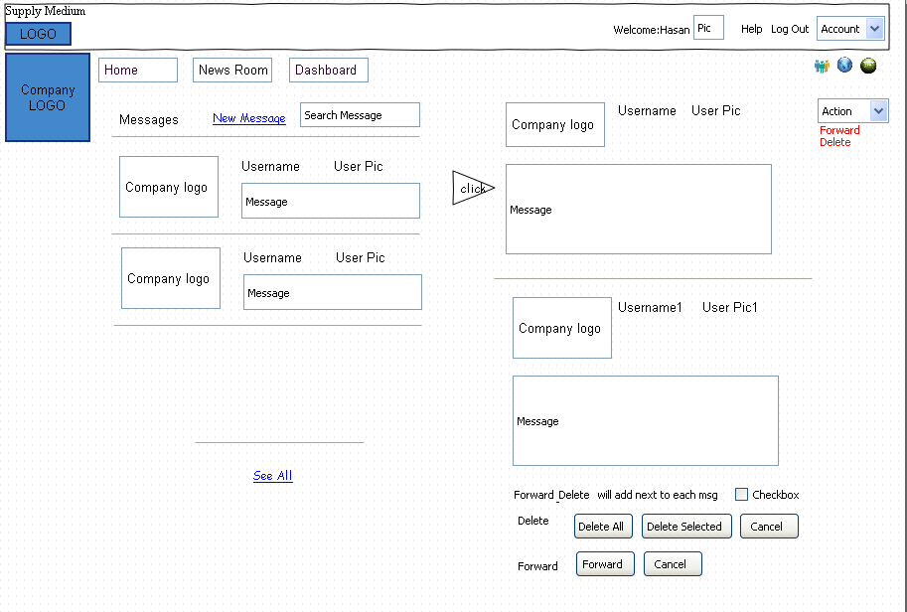

**Notifications**

* These will be based on similar to Facebook style with user getting alert notification in the middle icon clicking on which it takes him to the actual location.

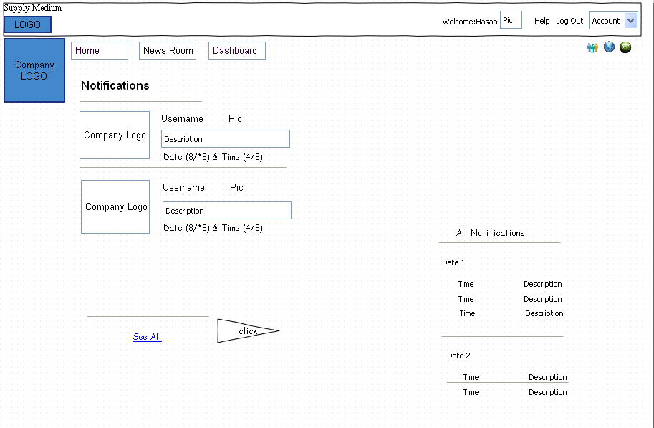

**Events**

* This is similar to facebook style too that allows user to create an event alert for any task

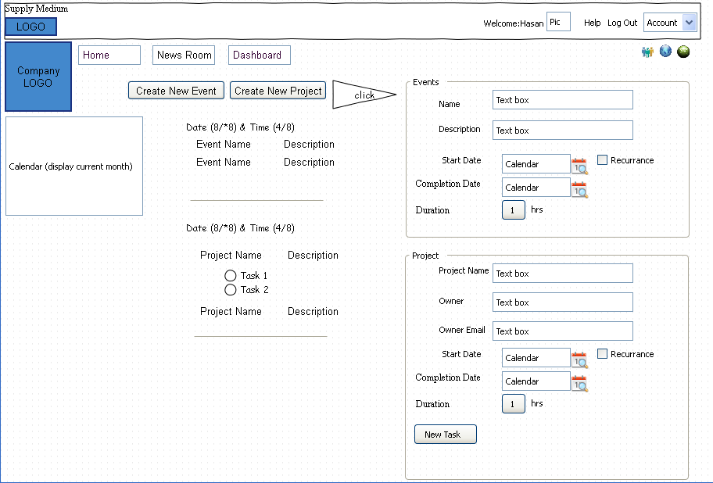

**Groups**

* This is similar to facebook style too that allows user to create a Group

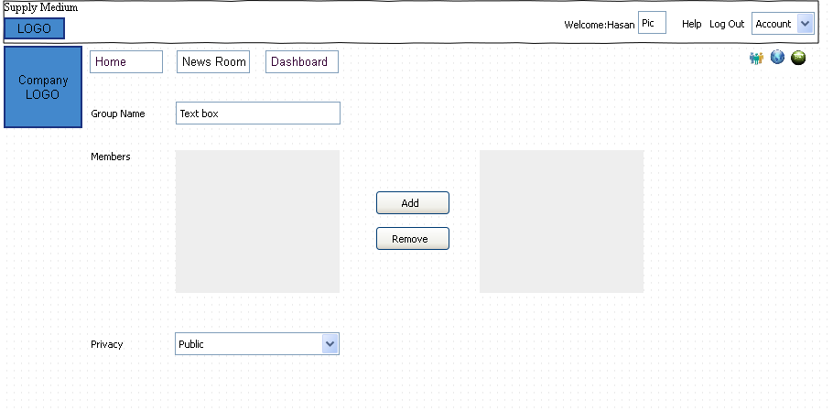

**Chat**

* Chat can be either internal with a company where they can communicate with each other or external to any users
* They should allow for exchanging any files

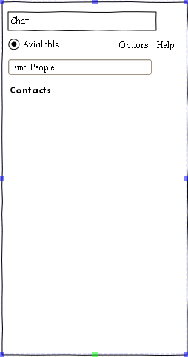

Rate Buyer/Supplier

User has the ability to provide feedback on their experience for the transaction by putting appropriate rating

